**World Leader Summit**

After watching 2022 G20 Bali summit, a group of students of intelligence system has an idea to make a **face recognizer** to **recognize world leader’s faces** for their final project. They planned of **using dataset** from the **following website**. You as one of the team members and an assistant candidate, you are asked to help them.

You are required to implement **Local Binary Patterns** for **recognizer** and use **classifier** from **python OpenCV** module.

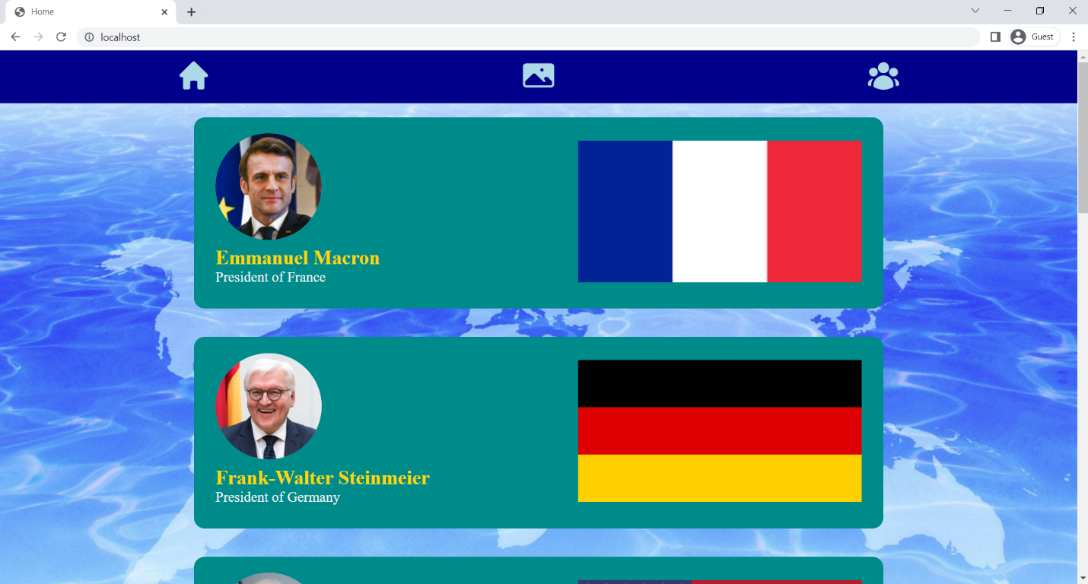

**Figure 1. Home Page**

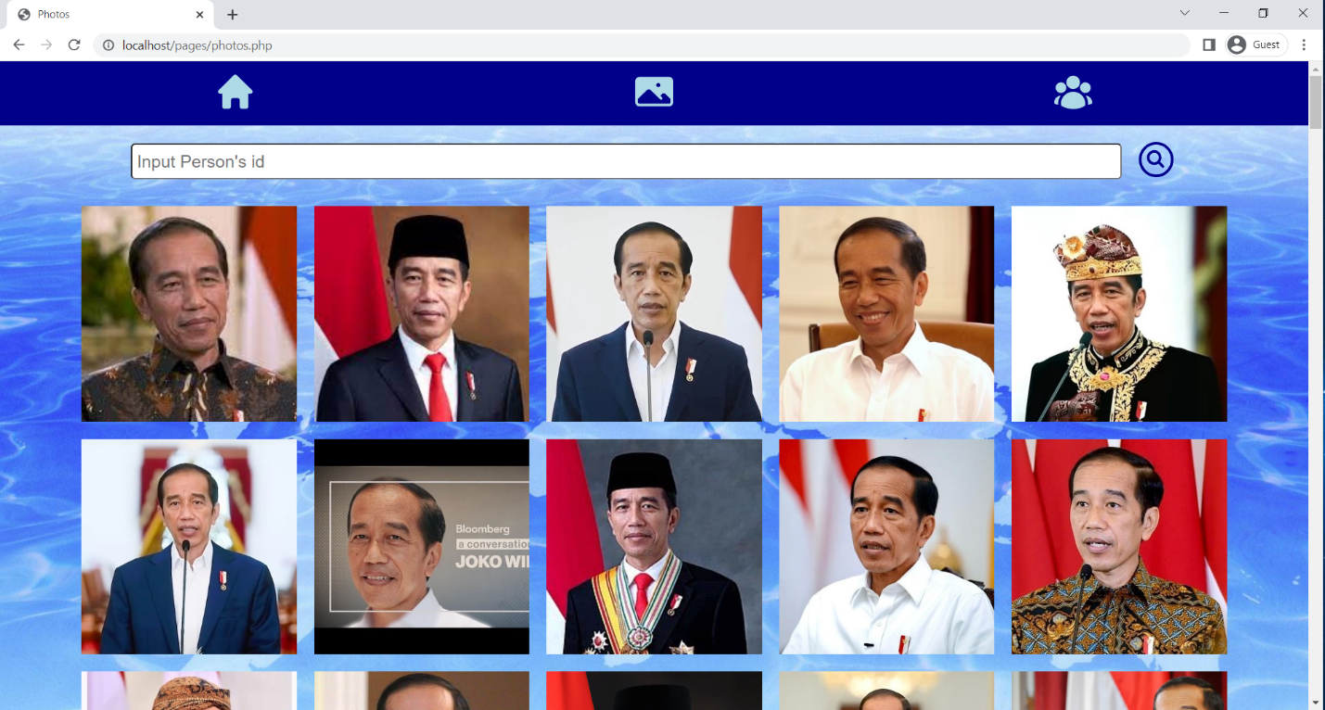

**Figure 2. Album Page**

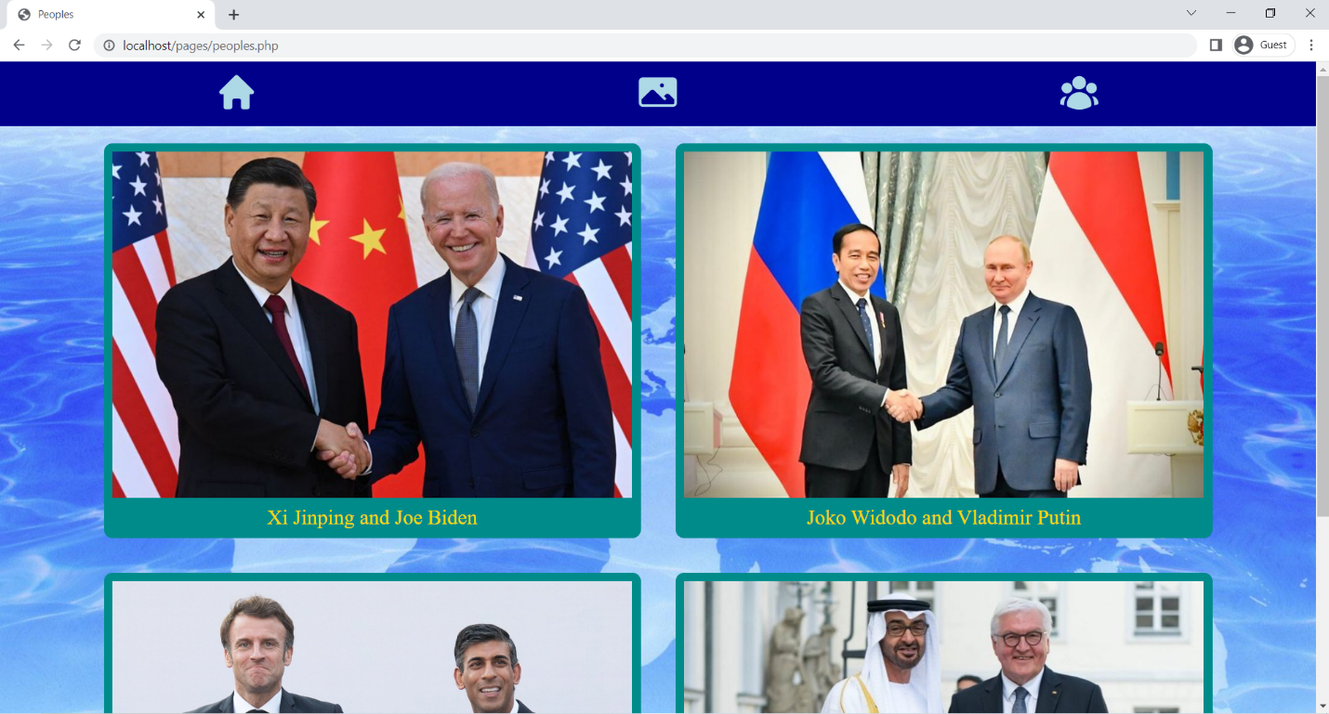

**Figure 3. People Page**

You are given 4 template files and asked to:

1. **Model.py**

* **Define** **model** and **classifier** class.
* **Use OOP concept** for model and classifier.

1. **Train.py**

* **Load image datasets** from World Summit website.
* **Split** **datasets** into **training and testing with 8 % test size** and **randomize** the datasets.
* **Make model**.
* **Train model**.
* **Save Model** into .yml file.
* **Test Model**.
* **Print accuracy**.



**Figure 4. Accuracy**

* **Display Confusion Matrix**.

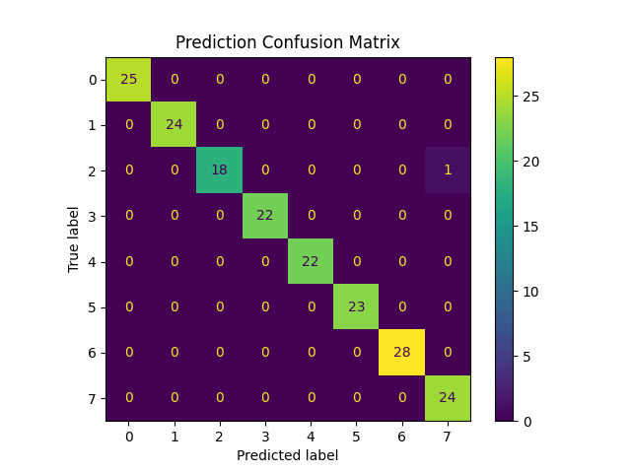

**Figure 5. Confusion Matrix**

1. **Test.py**

* **Load random 15 images** from World Summit website.
* **Define model** and **load Model’s data**.
* **Predict images**.
* **Draw face’s rectangle** and **print name on each image**.
* If image’s prediction is **correct**, **use** **green color**. **Otherwise**, **use red color**.
* **Display** **all image** result.

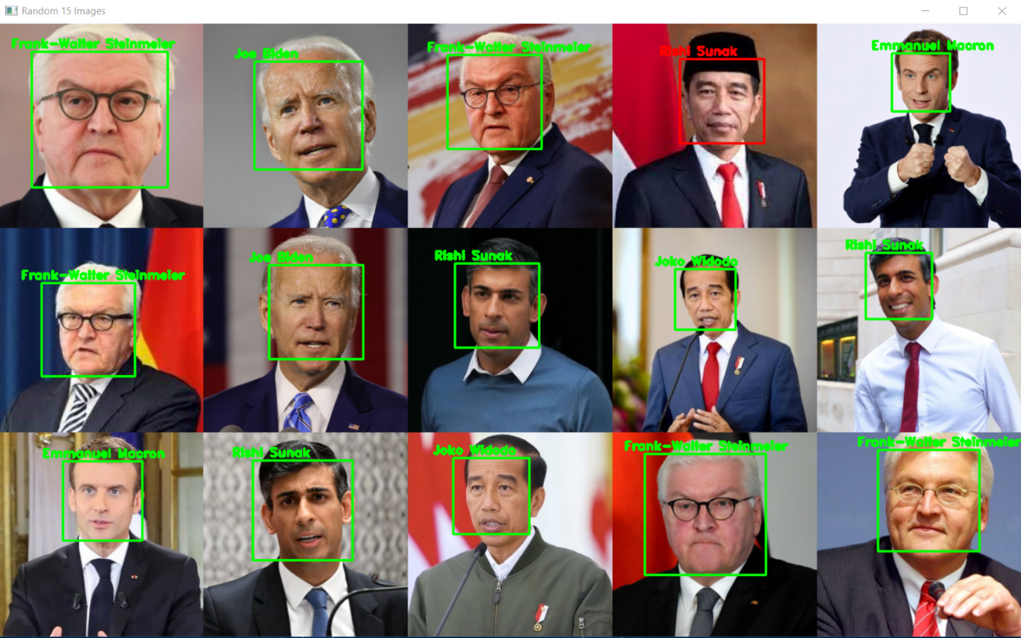

**Figure 6. Display with a False Prediction**

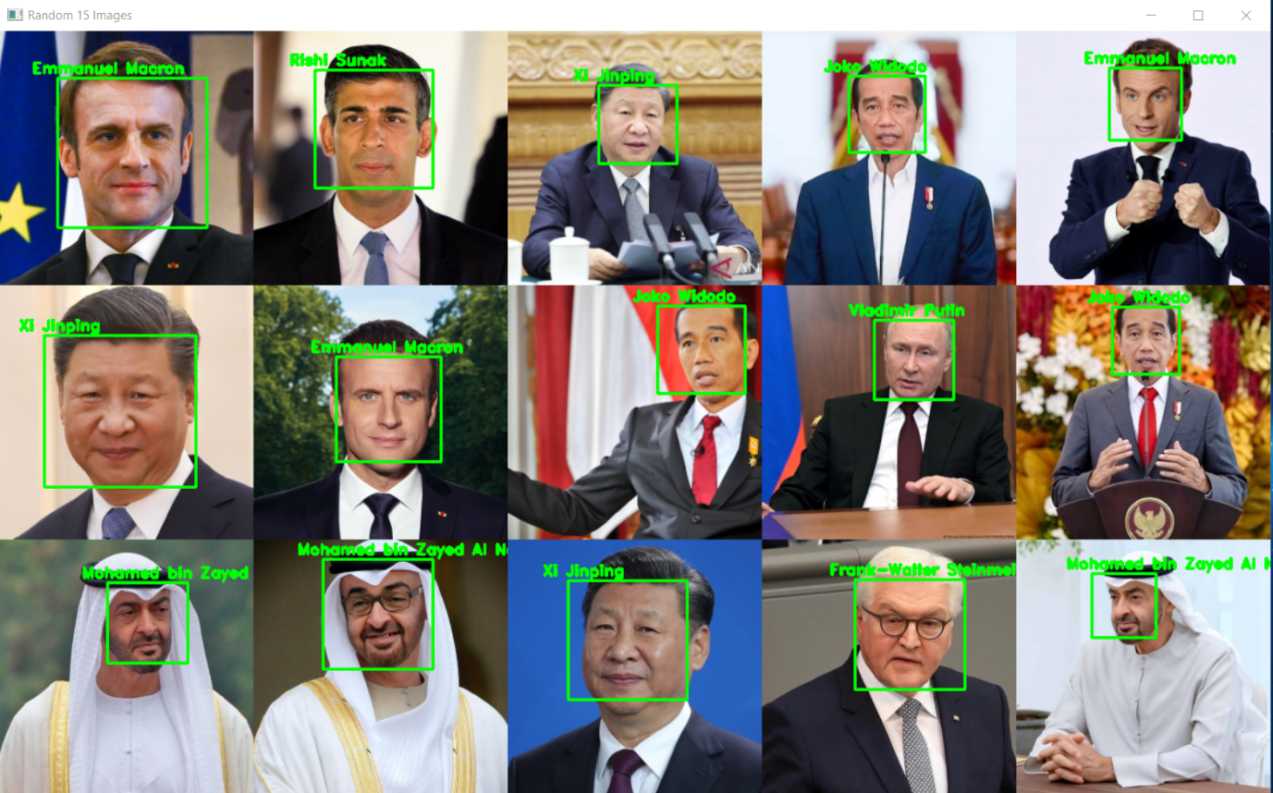

**Figure 7. Display with all True Prediction**

1. **Test2.py**

* **Load images** from World Summit website people’s page.
* **Define** **model** and **load model’s data**.
* **Draw face’s rectangle** and **print name on each image**.
* **Display all image** result **using matplotlib**.

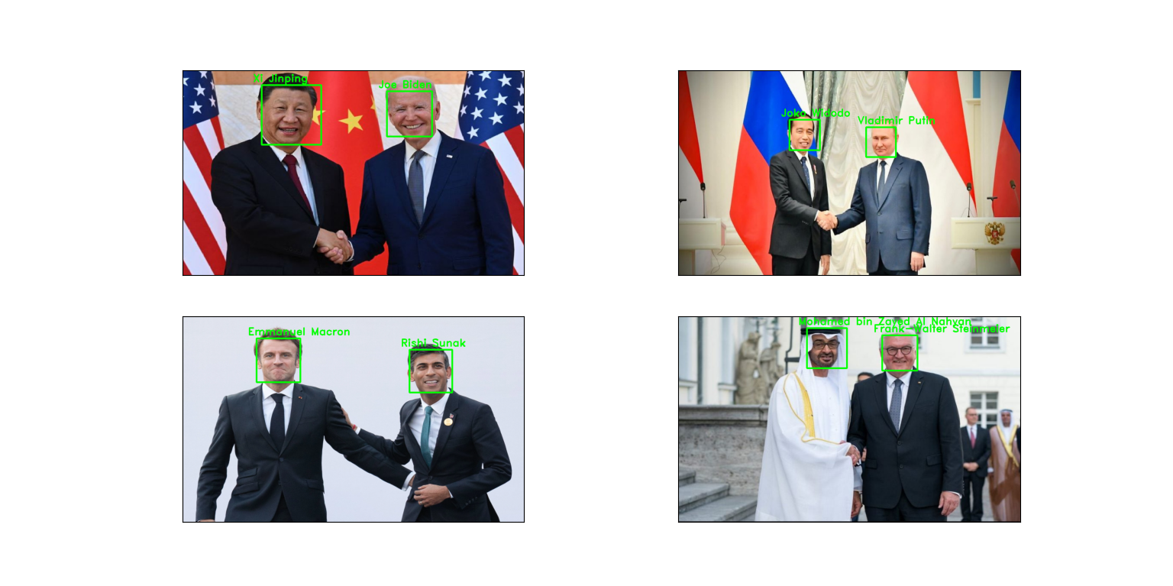

**Figure 8. Final Image**

**Important Notes:**

* You may **only use modules** from **requirements.txt**.
* To **improve** model **accuracy**, you can **modify the datasets** such as image augmentation.
* You may **modify the function’s parameters** on the template according to your needs.
* You may **create your own helper function or files**.
* **Put** website’s url and model data’s path to **.env file**.

**Score Template:**

|  |  |
| --- | --- |
| **Criteria** | **Score** |
| Train | 24 |
| Test (Predict 1 Face) | 22 |
| Test2 (Predict 2 Face) | 20 |
| Miscellaneous | 34 |